Data Structures Project Final
Ian Waddell
11/30/18

Project Proposal
I decided to do a reservation list for a self-storage facility. The reason I chose this project is because I work in the field and I would like to improve upon the current system which is near non-existent. The current issue is the system is simple someone sends an email and that is it, it doesn’t have a list, it doesn’t have any information and all we have is what the customer has given us in that email and to find the customers information later we must find that email. Which the emails do have timestamps however it’s a very sloppy way to hold onto customers information.
I decided to focus on having a way to save and make a list. Our policy is first come first serve so the queue data type was perfect. However due to the different options that our facility offers one queue structure is not enough, because of this I needed to figure out how to split the information that was being inputted. After giving it some thought I couldn’t come up with a fancy or interesting way to handle this issue. So instead I decided I would just make six queue’s and then make the interface easy to use. I plan to use multiple choice to select which size spot the customer is wanting. The end goal for this is when a customer makes a reservation the employee inputs the information into the system and then when a spot of that size comes available, the employee clicks on the box and then looks at the first of the queue calls the person and then removes them.

My current timeline plan:
- Decide on what I am wanting to use for the data structures mainly the second data structure. Which I would like to use to view the entire list in the order that is was inputted for this I am planning on using a linked list.
- I plan on deciding what I want the gui to look like, the current idea is to make the information inputs to be on the left side with the options to choose which unit size the customer is wanting on the right.
- I need to decide what buttons I need for the application since I need to make sure the gui is easy to use. Due to the fact there is going to be six plus data types I need to first make sure that It doesn’t look like there are so many that would make it confusing.
- Then the plan is to start making the gui, I will need to go back and look at how to make a gui since it has been so long since I have worked on making one.
- After making the gui look satisfactory I need to make the code, but while I do this, I need to make sure that my previous design was enough. I have a feeling that I will need to change the layout especially for the buttons.
- Once I have the coding done then comes the testing and retesting to make sure the program is easy to use and Is easily understandable. I need the outputs to be simple and the controls to be as well. It is important that anyone is able to use the program.

Time/Change Logs
Week one: For the first week I mainly focused on what I was going to add onto the program. Was I going to start with everything that we have to offer via storage units and camper spots or should I only do storage units. I decided to go for all the options we have and if it was too much to try but cut back if needed.
Week two: The second week I ended up working on the gui and got close to finishing it. I mainly focused on what I thought I was going to need and made sure to give a little space and mark things clearly in the code so if I needed to add anything later that I could jump straight to it. I also did the code for the input.
Week three: This week I focused on the code for the program. Trying to finish the input and the output. I did make a mistake the week before for the input, so I had to fix that it wasn’t to hard to do, I then made the basics for the buttons. However, I will probably change the placing later.
Week four: I decided to finish the remaining code for the project due to some free time I got. I was able to program one linked list that took in all information for each reservation and put them into a list in the order that they were received. As well I was able to finish the six queues which each one taking information only when they were selected in the multiple-choice box.
Week five: For the last week of the project I mainly focused on trying to fix small bugs and make the program more presentable. I also tried once again to save information permanently however I was unable to do so. After moving a few things around I believe this to be the best basic layout that I can offer. One that is easy to use and when a employee looks at it, they immediately understand how to use it.

Lessons Learned
During the start this project I ended up re-learning a lot of the basics that I had learned in java one, that I had kind of forgotten. Mainly I needed to learn how the gui worked and how to place everything. Since I had already learned this before it didn’t take long, I just needed a refresher. The main issue I ran into the first few weeks was I didn’t know how to permanently save the information. I wanted to make it to where once the program is terminated it still retained the information from the previous run, unfortunately I am not skilled enough to do that and I had to let that idea go early on.
Towards the middle of the project I had originally planned to make a two window gui one that focused on the information inputting and the basic showing of the first of each queue and a second window that focused on the linked list output. I ended up having to make the entire thing just one gui however I kept the linked list in the console, so it is still able to be read in its entirety.
Now that I am towards the end of the project, I am proud of the base line I have made so I have started on the final presentation of the program. During this time, I have also learned that I dislike github and it was far more difficult then I would have originally thought to upload my project code to it. But now that everything is uploading, I look forward to making the video describing and showing off my self-storage reservation program.

Code and Project Show

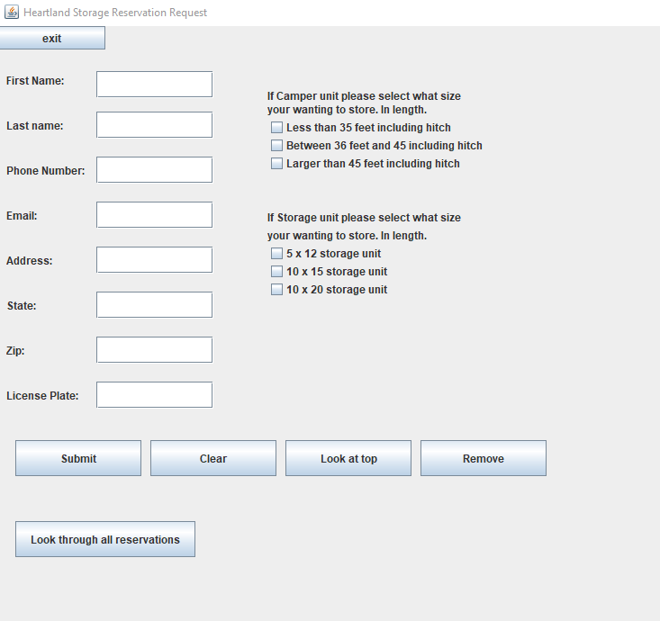
This is the gui for my program on the left it has the information inputs on the right it has the selection of what type on unit the customer would like to have.
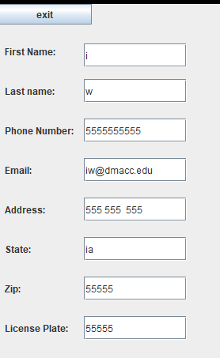
For this example, I have inputting information in then I would click one of the selectors on the side and that decides where it goes in the data structure.
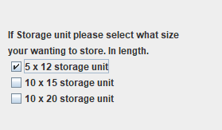
Now this is the output that I would get for that information first when clicking submit the bottom changes and words appear saying information has been submitted.
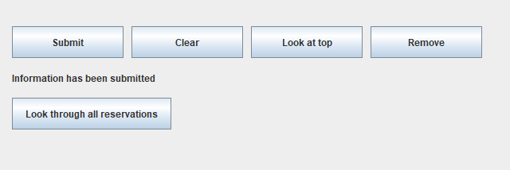
Then you can click on clear to clear the boxes and the output label to input someone else or if you have something come available you can simply click look at top. 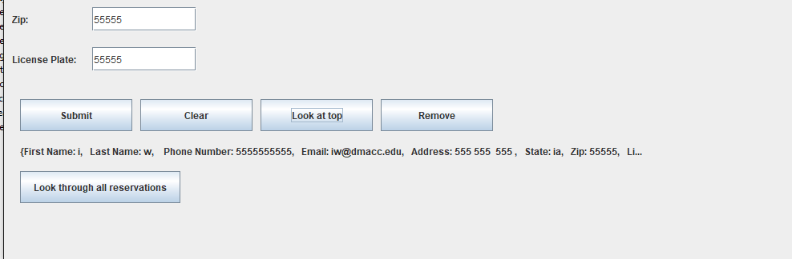
Which provides this information. Due to some request having a little more information you can use the link list to output all the reservations to find out all the details as well as see all the orders in the order that was inputted.
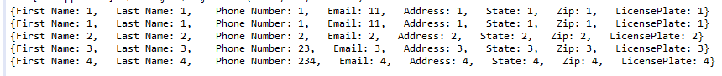

Conclusion.
For the conclusion of my project I would like to state why I believe my program followed the MERUSE principle of good programming. To start with modular, my program is modular due to the ability to take in information on multiple databases with the change of a box. Due to the six boxes on the right side of the gui it’s easy to continue to input information without having to change ether the program or by going another route and changing the exact database that you want the information to be saved in.
The second efficiency was a focus of this program, it needed to be simple enough that any employee can use it, as well as use it quickly. When it comes to customers the faster everything is handled the happier, they are. Due to this fact it was important to make everything clear, the employee asks for information, inputs the information, saves it then moves on. Due to the few options of this program I believe this completes that objective.
I believe my program to be robust in the simple fact that it can take in nearly any information easily. I understand that normally you would to have a limit to how many characters that should be allowed in the first name, last name, and the other input fields. However, I believed that to not be needed for this program. The reason I decided to go this route is mainly due to the fact there is not a log in system which could easily cause errors or smaller issues when a username or password becomes to long. I do believe in a simple reservation list such as this one it is better to get all the information that is given. Due to there not being a limit to the input information the errors for the program should be near none.
When it comes to usability, I believe that that this subject goes with efficiency, the programs focus was to make things simple enough for any employee to use without having a large amount of training into it. I did originally think that it would be possible for customers to use this program as well. However, due to the ability to look at people’s information I would have to make a slightly modified program that did not have the ability to see people’s information. However, I do believe due to the simplicity of this program that a customer could easily use it as well.
When it comes to elegant, I do believe that the simplicity to this program makes it elegant the ability for anyone to look at it and know what they are supposed to do I believe is nice. The system is basic but gets the intended job done.
I mentioned this earlier but throughout the entire project especially with the main code page I tried to keep all elements in the same area and kept comments of when certain objects were being made and when they were finished. Then I would have one line of space then another comment saying //start text field. I tried to do this as much as I could to make it easy to jump to the code that I might need to change. This turned out to be a great idea because my first layout was not the finished product. Due to this I believe my code to be easy to read and understand.
While I did quite a bit for this program there are a few features that I will be adding in the future once I become more proficient with java. The first would be to make a second gui specifically for the linked list ADT that has more options such as remove and searching. The second would be to make the program have the ability to save the information permanently. This is important feature and until this part is done, I can’t use it properly. While you could at the end of the day click the link list and copy and paste the information into a reservation dock it would defeat the purpose of having an all in one reservation program. The last would be to make a customer side of the program one that is just information input not having the ability to look at the information that was saved. However, while this would be good to have for ether online or having a tablet for customers to put in their information it may be a hinderance on for employees. So that option would have to be visited later and tested however I believe it to be a valid option.

Video Presentation Link
Ging: https://www.screencast.com/t/G1MJgT2yr
Youtube: https://youtu.be/ndTCdJmuvlc

